**SISTEM TERDISTRIBUSI**

**DOMAIN NAME SYSTEM**



**Zahra Hanifa**

**09011182126025**

**FAKULTAS ILMU KOMPUTER**

**JURUSAN SISTEM KOMPUTER**

**UNIVERSITAS SRIWIJAYA**

**2024**

**-nslookup**

1. facebook.com

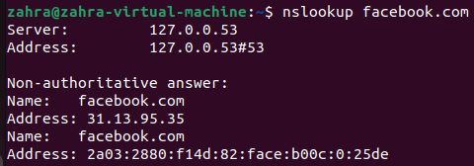

1. instagram.com

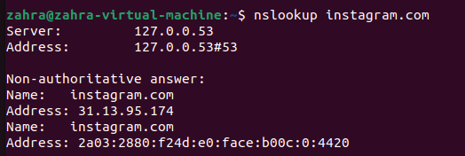

1. youtube.com

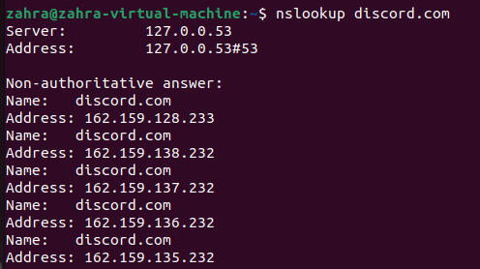

1. whatnssapp.com

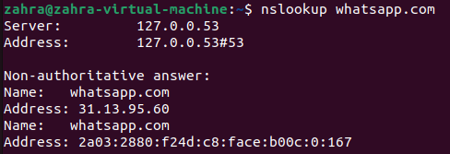

1. twitter.com

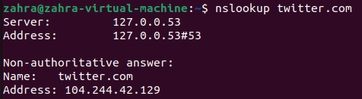

**-dig**

1. amazon.com

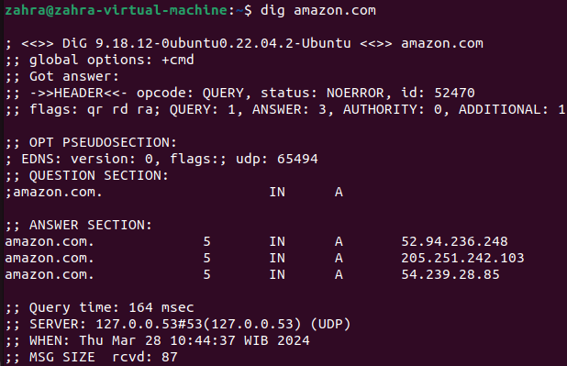

1. spotify.com

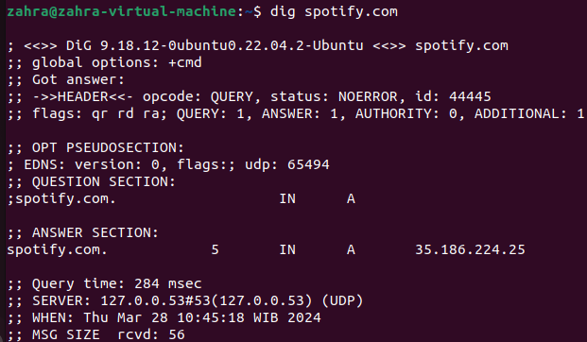

1. zoom.com

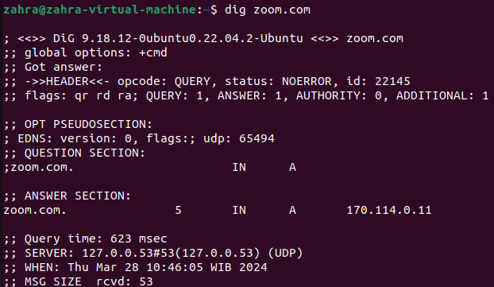

1. grab.com

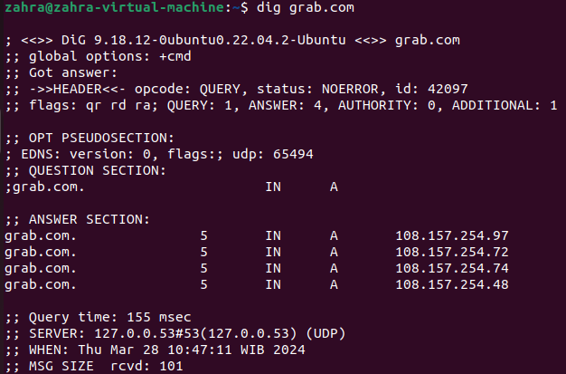

1. telegram.com

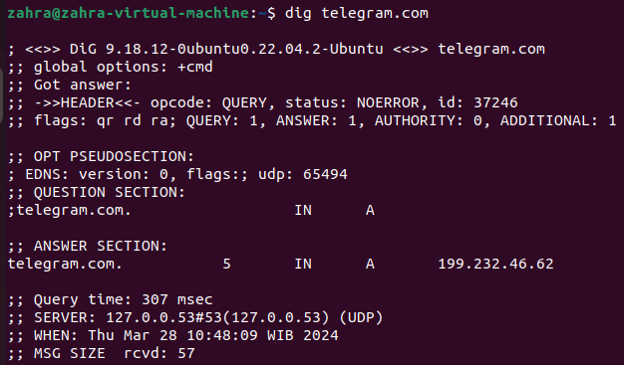

**-nmap**

1. telegram.com

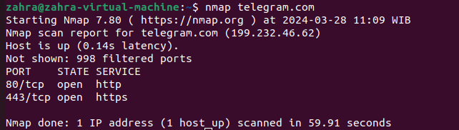

1. youtube.com

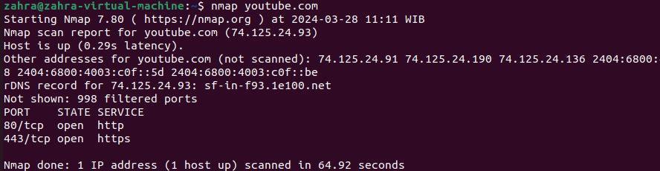

1. discord.com

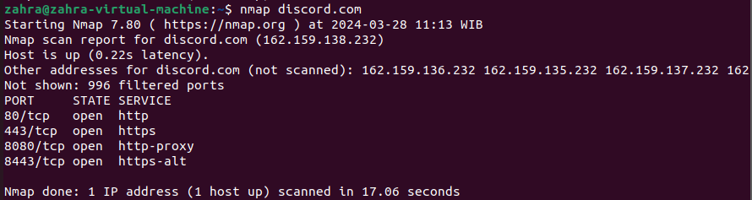

1. bstation.com

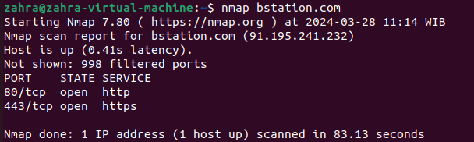

1. wattpad.com

